How to load a Property into the Market Place

First Create your Market Place Profile:
Click on the drop-down box
Log on to MyOta

Click on the Market Place Profile

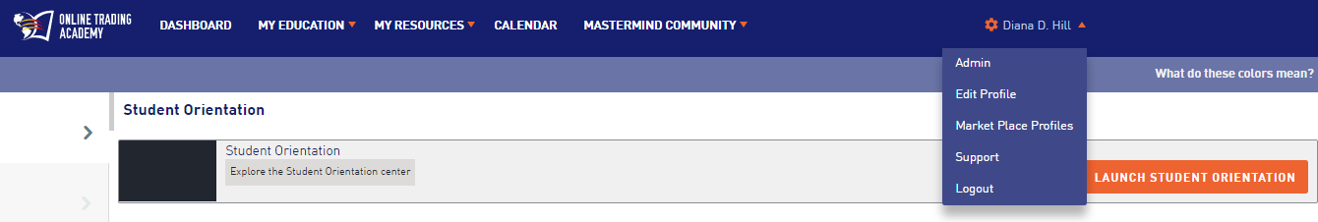

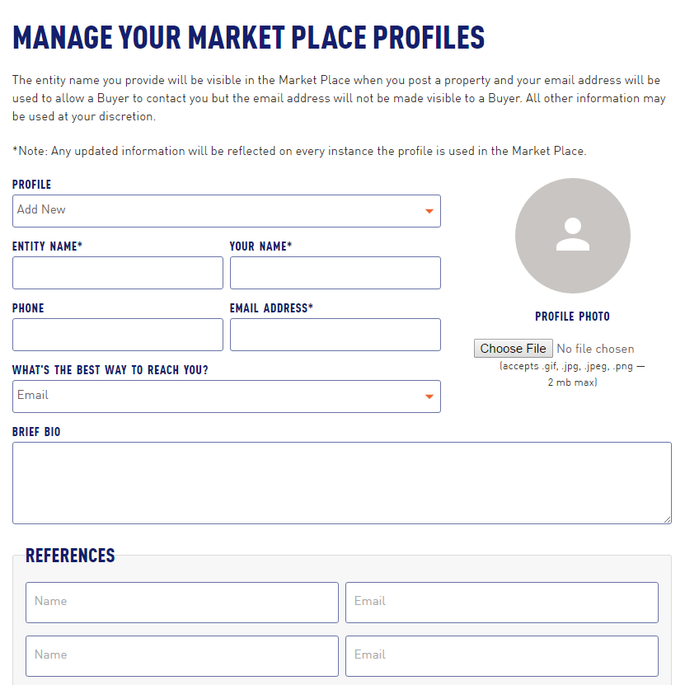
Please note there are required fields. Otherwise the additional information you choose to provide is up to you.

Once your profile is set up continue to the Deal Tracker:
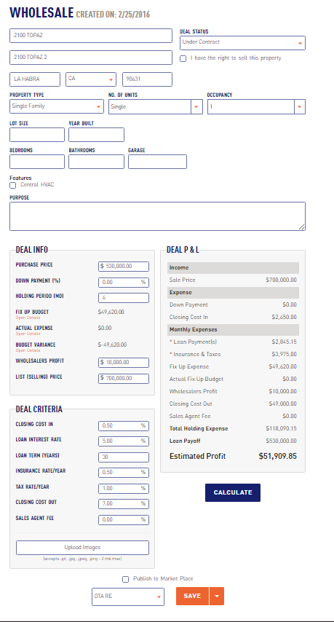

Under Deal Status – Under Contract must be checked and you must click the box that says “I have the right to sell this property”
All required fields must be filled in
Your ad will be more powerful if you include images 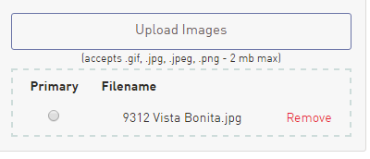

Then save and check the Publish to Market Place
You then need to choose which Market Place Profile you want to use.
Then your property will be displayed in the Market Place
