Pencil Tool:
Pick a starting point:
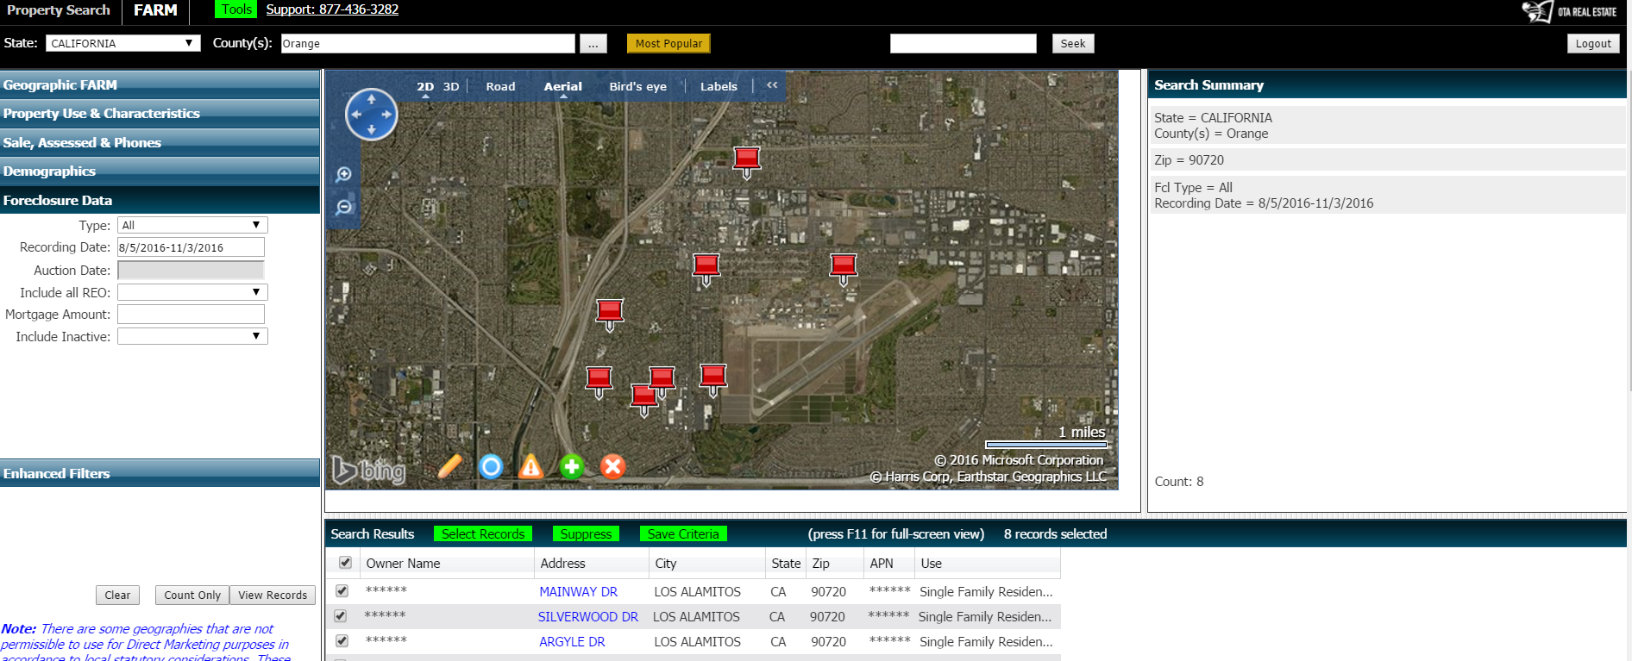

Click on the Pencil tool
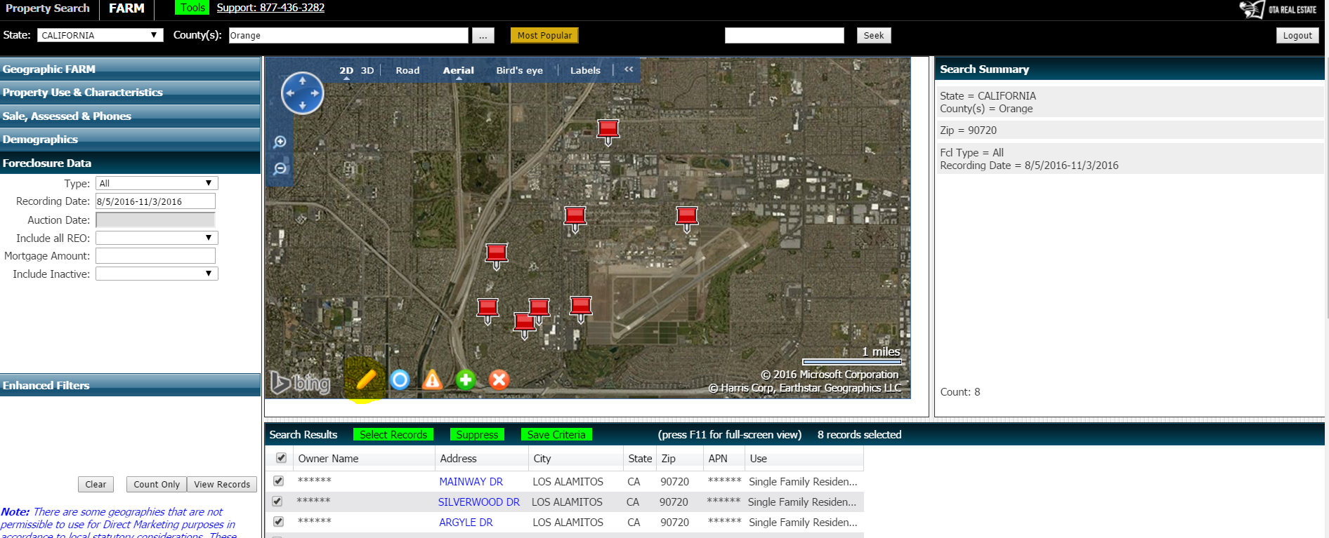

Now click your starting point with a right click and drag the cursor to make your shape at each turn use the right click – don’t close the shape.

