Farm Report:

Click the Convert to PDF button

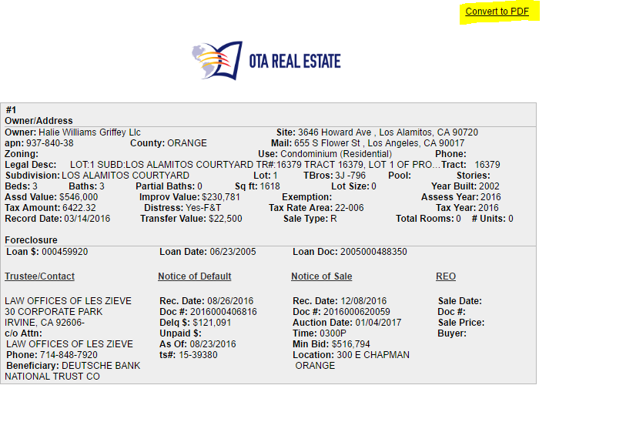

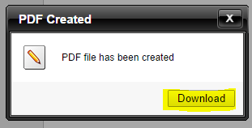

This screen will then appear click on download



Once downloaded open and save (we suggest you change the name)

Property Profile report:

Click the Convert to PDF button (not suggested you used the link for email it only last 24 hours)

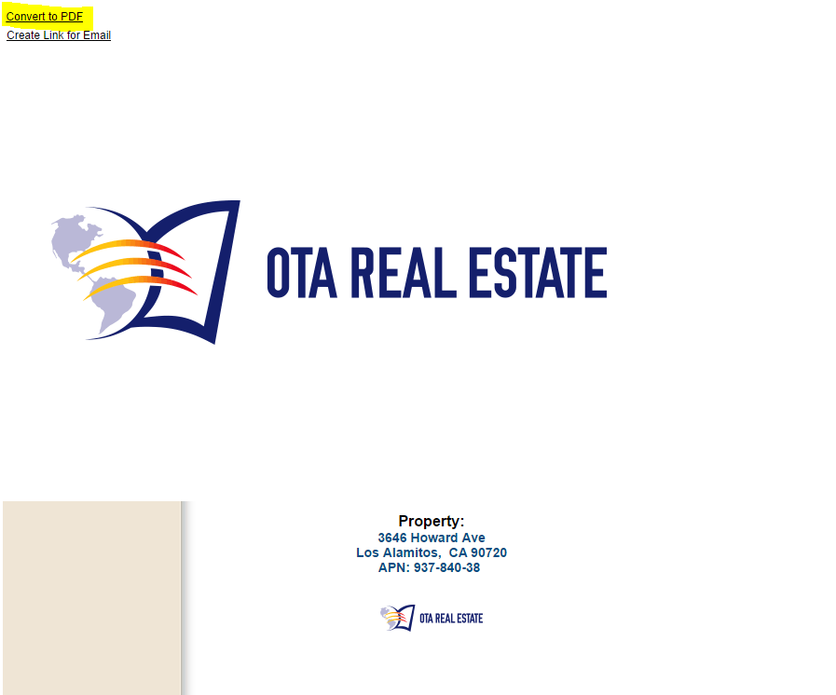

Follow the same steps as above

Download and save